***Global Electronic Data Insights and Action Items***

## Insights:

Note:Please try to open it in google docs for better visibility.

# **Customer Analysis:**

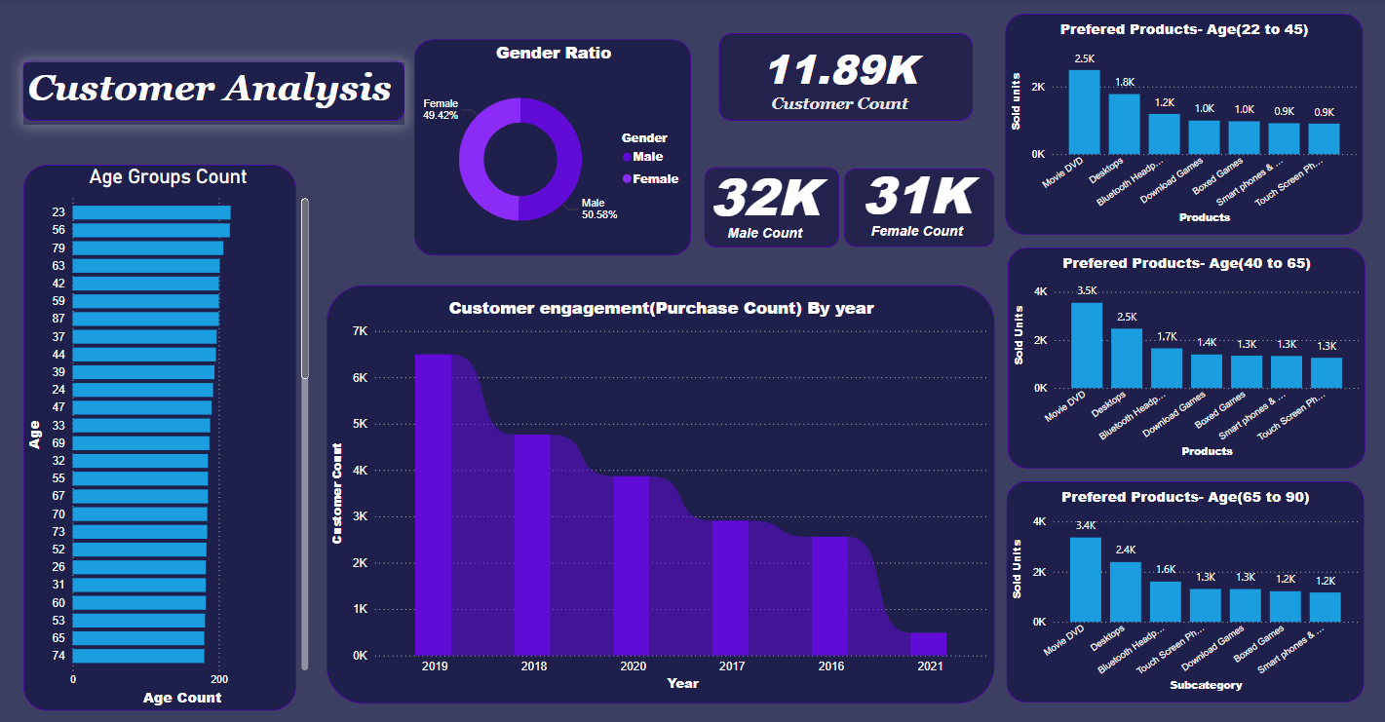

**Top Age Groups:**

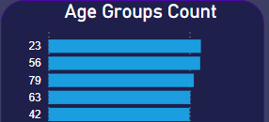

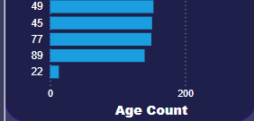**Least Age Groups**

## **Customer Count & Customer Spread Between Age Groups:**

* The Data shows that the Global electronic company has a customer Count of 11.90K
* The gender distribution is nearly balanced, with 50.58% males and 49.42% females.
* The Age Group distribution has a High count at the age of 23 and have a lowest count at the age of 22 the age spread is almost same in middle age 25 to 50.

## **Customer Engagement Over Time:**

* Customers have a Highest engagement at 2019 and 2018 periods but there is a sudden drop in the engagements between 2020 to 2021.

## **Products Preferences by Age Groups:**

* The Age group between 22 to 45 and 40 to 65 and 65 to 90 have almost the same interest likeMovie DVDs ,Desktop PCs, Bluetooth Headsets. But the age group 40 to 65 are purchasing more than the other two age groups.
* The Age Groups 65 to 90 shows less interest in Smart Phones than Touch screen phones. Maybe they have less interest in Smart gadgets.

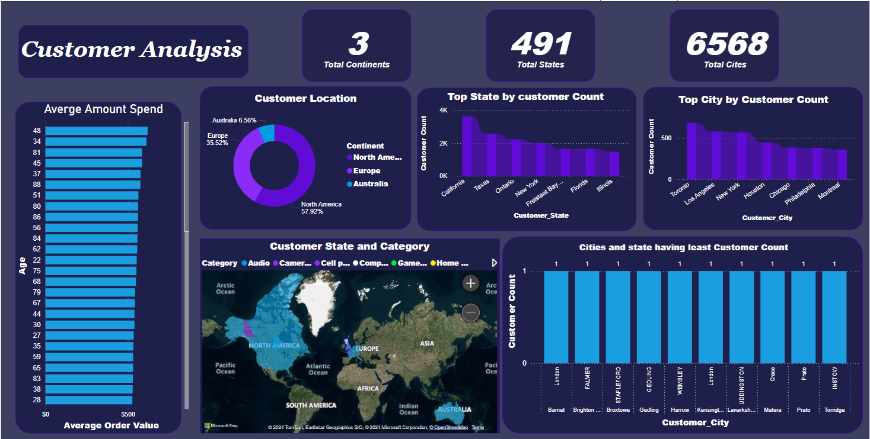

## **Geographical Distribution:**

* The majority of customers are from North America (57.92%), followed by Europe (35.52%), and a smaller portion from Australia (6.56%).
* California, Texas, and Ontario have the highest customer counts. California is the top state in our customer base.
* Los Angeles, New York, and Toronto are the top cities in terms of customer count, with Los Angeles leading.
* There are multiple cities with only a single customer, spread across various regions, including London, Barnet, and Prato.

## **Average Amount Spend by Age:**

* The top age group who are spending more average amounts are 48,34, and 81 and the least spending age group 36,85,24 and between this age group they average spend is almost similar.

## **Customer Distribution:**

* The customer is spread around 3 continents in:North America,Australia and Europe and in around 491 total states and 6568 Cities the Global Electronics have their customer Base.

# **Sales and Products Analysis:**

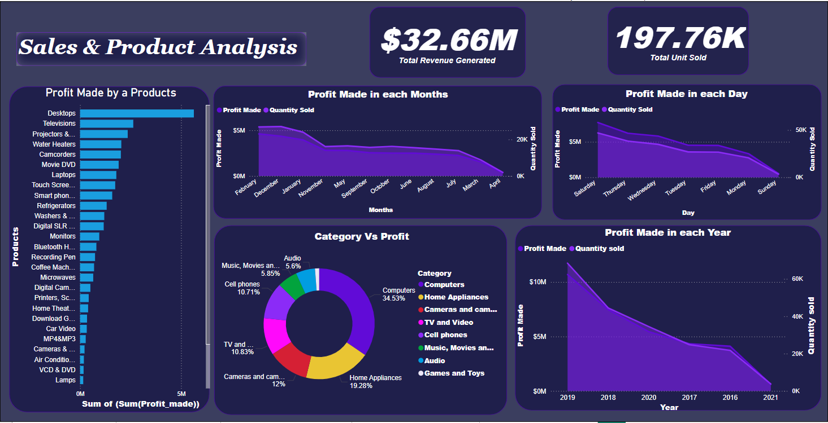

## **Total Revenue and Units Sold:**

* The company has generated a total revenue of $32.66 million.
* A total of 197.76K units have been sold.

## **Profit by Products:**

* Desktops and Televisions,Projectors & Screens,Water Heaters are the top profit-generating products, with Desktops leading significantly.
* Products such as Lamps, VCD & DVDs, and AC,Computers Accessories,Boxed Games contribute the least to profits.

## **Profit Over Time:**

* The profits in 2019 are high but there is a drop in the 2020 and 2021 as seen in the customer analysis.
* The Profits in the start and end of the year is high but in mid year there is a significant drop in the profits.
* The start of the Week such as Sunday and Monday have less profit than the mid and end of the week. There is a high profit in saturdays.

## **Category vs. Profit:**

* Computers: Leading category, contributing 34.53% of the total profit.
* Home Appliances: The second-largest contributor at 19.28%. And camera at third contributing 12%
* Low-Contributing Categories: Categories like Audio and Games & Toys contribute the least to the overall profit.

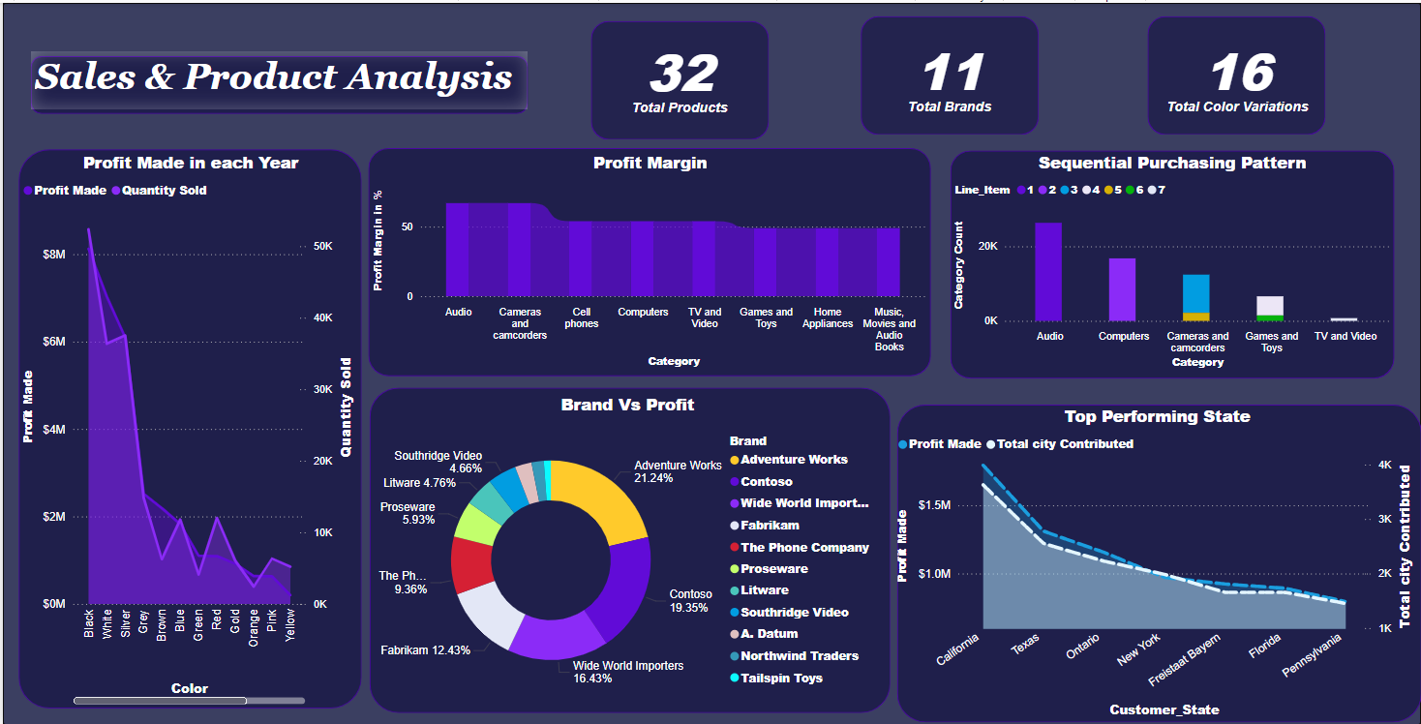

## **Profit Distribution by Color:**

* Black products are generating the highest profit, followed by white and silver. The profit drops significantly for other colors, indicating a strong preference for these top three colors.
* Quantity sold also correlates with profit, suggesting that customers prefer these colors, driving higher sales volume and profits.

## **Profit Margin by Category:**

* Categories like Cameras and Audio(67%) ,Camcorders(67%), Computers(54%), and Cell Phones(54%) have the highest profit margins.
* Lower margins are observed in categories like Games and Toys(49%), Home Appliances(49%), and Music, Movies, and Audiobooks(49).

## **Sequential Purchase Patterns:**

* There is a pattern between purchasing the customer who buy Audio categorical products will buying Computers then Cameras and Camcorders and Games ad Toys and Tv and video.

## **Brand Vs Profit:**

* Adventure Works is the leading brand, contributing 21.24% to the total profit, followed closely by Contoso and Wide World Importers.
* The top three brands account for nearly 75% profit of the Global electronics shows the customers preferred Brands.

## **Top performing States:**

* The top performing states are california, texes,ontario,New York,Freistaat Bayem,Florida and Pennsylvania which have a cities count between 5k to 1k which lead to make a high profits.

# **Sales and Store Analysis:**

## **Profit by Store Size (Square Meters):**

* Larger stores (in square meters) generally generate higher profits. However, there are several mid-sized stores that also contribute significantly to the profit which shows the size is a factor but it won’t affect the profit too much.

## **Open Date vs. Profit Made:**

* Stores opened earlier have made significantly more profit over time when compared to stores opened more recently. This suggests that new stores may take time to become profitable or that older stores have established a more loyal customer base.

## **Profit vs. Store Country:**

* The United States is the most profitable country by a large margin, followed by the United Kingdom and Germany. Other countries like Canada, Australia, Italy, and France contribute little lower than canada,Australia to overall profits.

## **Category vs. Profit:**

* Physical stores account for a significant majority (79.57%) of the total profit, whereas online sales contribute only 20.43%.This indicates that the company is strongly dependent on the Physical stores than online.]

## **Profit Made vs. Store State:**

* Nevada, Kansas, and New Mexico ,Oregon are the top-performing states in terms of profit made and the caltanissetta,Martinique,Limousin and generating the mid level of profits.

## Action Items:

1. There pandemic in the year between 2020 - 2021 the is a drop in the customer engagements to increase the engagements again introducing loyalty programs, exclusive offers, and targeted marketing campaigns to re-engage past customers, particularly those who have not made a purchase in recent years.
2. Implement feedback systems to understand the reasons behind drop in engagement. Customer surveys and reviews could provide insights into what might have changed in customer preferences or market conditions.
3. For Age groups like 22 to 45 - introduce more advance product of the Movie DVD’s and find out current trends by competitive analysis and give a buy two get one free and free bluetooth headphone.
4. For Age groups like 45 to 65: They are trying different product groups newer and older try experimentation in a high customer state like California, Texas, and Ontario for getting know about which product attract them so based on that increase the quantity and ads.
5. Since due to covid most of the customers prefer online shopping rather than the offline this is the major reason for the downfall in 2020 to 2021 for increase the customer need to check a customer interest through survey and run ads more specific age and state first try in countries we already having a loyal customer after analysis that we will get an idea and we can push to wider audience.
6. Customer base peaks around mid-30s, there’s an opportunity to engage with younger audiences (below 30). Use social media, influencers, and digital marketing campaigns targeting younger customers to broaden the customer base.
7. Since North America dominates the customer base, there is potential to expand marketing and sales efforts in Europe and Australia.
8. For regions and cities having low customer count run a fun events and host a sports game to increase awareness among the peoples it will make people to know about us.
9. For increase the average spend by the each age group give a buy 2 get 1 offers and also place a right product at right place to increase visibility of a needy product in online run a social media marketing with some offer by clearly knowing the target audience with their target products.
10. Instead of selling lots of varieties in colors and subcategory, find for the high to medium performing products and drop the very low performing product.
11. Invest in marketing and expanding product lines in high-margin categories like Cameras and Camcorders, Computers, and Audio.
12. Analyze customer feedback to understand why certain categories like Games and Toys have lower margins and explore ways to optimize costs or improve pricing.
13. By using the popularity of the brands like Adventure Works, Contoso, and Wide World Importers introduce the new trending products.
14. Consider partnerships or co-branding opportunities with these leading brands to further enhance customer loyalty and increase the profits.
15. Analyze the most profitable stores in terms of their size and layout to identify best practices. Consider applying these insights to underperforming stores or when opening new locations to maximize profit.
16. Continue investing in the in-store experience with upgrades and customer service improvements
17. Focus on enhancing operations in the U.S., U.K., and Germany, where profits are highest.
18. Promote the products which have a higher profit margins to gain the higher profit.
19. Since there is a drop in sales in the mid years such as august,june,july and also on Sundays and Mondays, introducing seasonal offers and additional discounts in these days will increase sales.
20. Check the cause for less purchase in online may be there is a complexity in handling, or there may be server issues etc try to find out the issue and fix it to increase the online sales.

By doing all these improvement there will be significant improvement in the profits.